**Peak Potential – MRD**

**Vision**

For college students and young professionals who struggle with staying consistent and disciplined in their fitness routines, Peak Potential is a new fitness accountability app that provides a science-based solution to make it easier for users to build the habit of going to the gym and stick to that habit. Unlike competitors that only focus on designing a gym exercise program, we offer a positive reinforcement strategy through gamification techniques, motivational quotes, and community support to make the user stick to the habit of exercising.

**Motivation**

**Personas (appendix 1)**

### Primary Persona: Ian

* **Demographics**
  + Age: 21
  + Education: Economics student at NU
  + Fitness Habits: Goes to the gym three times per week
  + Current Priority: Staying healthy without letting fitness dominate his life
* **Goals**
  + Maintaining a consistent gym routine despite a busy schedule
  + Tracking progress effectively to stay motivated
  + Achieving a healthy lifestyle without spending too much time or money on fitness
  + Building accountability by connecting with friends who share similar fitness goals
* **Frustrations**
  + Struggling to stay consistent when life gets busy, often taking extended breaks
  + Finding it hard to balance fitness goals with academic and personal responsibilities
* **Needs**
  + Personalized fitness plans tailored to his goals of staying healthy
  + Simple and intuitive tracking features for workouts
  + A supportive community of like-minded peers for accountability and motivation
  + Solutions that adapt to his fluctuating schedule

### Secondary Persona: Emily

* **Demographics**
  + Age: 27
  + Education: Business Administration
  + Fitness Habits: doesn't have a specific routine
  + Lifestyle: Balances work, hanging out with friends and goes to the gym if there is nothing else to do.
* **Goals**
  + Staying active and reduce stress through fitness
  + Improving overall fitness and flexibility without pursuing a strict gym routine
  + Finding sustainable fitness routines that work with her bussy schedule
* **Frustrations**
  + Always postponing the gym start date
  + Her friends are not always available to go to the gyms with her
  + Overwhelmed about the fitness content, not knowing where to start.
  + Not resuming the gym after the holidays
* **Needs**
  + A blend of home-based and light gym workout options tailored to her fitness level
  + Motivational features like progress tracking and gentle reminders to stay on track

### Early Adopters vs. Mainstream Users

* **Early adopters** are:
  + More inclined to explore innovative features, such as virtual classes, analytics, or gamified fitness tracking, emphasizing interaction with cutting-edge solutions.
  + Likely to actively engage with the platform's community aspects, using tools for motivation and accountability.
* **Mainstream users**, in contrast, prefer:
  + Solutions that offer convenience with minimal interaction, focusing on straightforward functionality rather than advanced features.
  + Simple, user-friendly interfaces that require less effort to navigate and utilize.

This distinction highlights the interaction dynamics between user types and the solution, showcasing how early adopters delve into feature-rich experiences while mainstream users prioritize ease and efficiency.

**Unmet Needs**

### Hypotheses for Primary Persona: Ian

1. **Hypothesis:** I believe that college students like Ian experience difficulty maintaining a consistent gym routine because of their fluctuating academic and social schedules.
2. **Hypothesis:** I believe that students like Ian struggle to stay motivated in their fitness goals due to a lack of clear, measurable progress tracking.
3. **Hypothesis:** I believe that students like Ian need a fitness solution that adapts to their busy lifestyle without requiring constant attention and time commitment.

### Hypotheses for Secondary Persona: Emily

1. **Hypothesis:** I believe that users like Emily find it discouraging to stick to the gym because they don't see any progress.
2. **Hypothesis:** I believe that students like Emily find it overwhelming to start going to the gym again, so they delay the start date.
3. **Hypothesis:** I believe that students like Emily seek someone to hold them accountable if she misses more than one exercise session.

**Methods used to collect evidence:**

1. **Interviews** 
   1. Sample size: 12
   2. 32 questions across 5 categories: User Persona, Exercise Habits and Preferences, Challenges and Motivations, Goals and Achievements, Resources and Learning, Financial Planning, Nutrition and Supplements, and Professional Guidance and Metrics
   3. Link to [Interview Data](https://docs.google.com/spreadsheets/d/1MLA0R_zlbkyrvTXQitQ_yu13mS1S7vNIRyE-wzXzDZk/edit?usp=sharing)

**Existing Solutions**

Existing solutions that target customers currently rely upon include apps such as MyFitnessPal, Fitbod, and Strava. These platforms address various fitness needs but have notable shortcomings:

* **MyFitnessPal**: Offers comprehensive nutrition tracking but lacks strong community engagement and advanced analytics in its free version.
* **Fitbod**: Provides personalized workout plans but neglects the accountability component.
* **Strava**: Excels in outdoor activity tracking but offers limited functionality for gym-based or strength-focused users.
* **Habit tracker:** Offers an intuitive approach to tracking multiple habits, offering charts, reminder,s and social features.

To validate these hypotheses about their insufficiencies, the team has gathered evidence through discussions with consumers who have used these products. These conversations revealed common frustrations, such as the lack of integrated features that combine fitness tracking, nutrition planning, and social accountability. Based on this evidence, a competitor feature matrix was created to highlight these gaps and guide the development of a more comprehensive and user-centered solution.

| **Feature** | **MyFitnessPal** | **Fitbod** | **Strava** | **Habit Tracker** |
| --- | --- | --- | --- | --- |
| Ratings | 2M 4.7 | 232K 4.8 | 304K 4.8 | 118K 4.8 |
| Workouts plans | No | AI-driven workout recommendations | Limited to running/cycling | No |
| Community Engagement | low interactivity; forums only | no social features | leaderboards, challenges, activity feed | Yes |
| Analytics | Basic (calorie and weight tracking) | Moderate (workout performance) | Advanced (GPS-based performance and trends) | yes, but generic |
| Cost Accessibility | Free version available; premium adds analytics | Paid subscription required | Free version available; premium unlocks advanced analytics | Free version available; premium adds analytics |

**Differentiation**

*Why are we best equipped to pursue this opportunity?*

1. **Exercise Habit-Building Focus:** Combines habit-tracking specifically targeted at achieving gym and fitness goals, rather than generic lifestyle tracking.
2. **Effortless Progress Tracking:** Simple UI to track the muscles trained, it can include weight or not.
3. **Community-Driven Motivation:** Fosters a supportive network for accountability, shared progress, weekly challenges, and scoreboards to increase motivation.
4. **Positive Reinforcement (view appendix 3)** : Daily fitness fun quotes, and progress notifications to keep the user motivated. Examples:
   1. “This month you have increased your gym attendance by 20%”
   2. "You don’t have to be great to start, but you have to start so you can look great."
   3. "Sweat is just fat crying."
   4. "Squats: because no one ever wrote a song about a small butt."
5. **Starting kit:** Science-based strategies and tips to increase habit adherence especially focusing on taking the first step.
6. **Freemium Model with Value-Added Premium Features:**
   1. Free Tier: Core tracking, habit-building tools, and community engagement
   2. Premium Tier: Advanced analytics, personalized workout plans, and AI-generated fitness recommendations.

**Why Now?**

*Has anything changed externally or internally that makes this opportunity available to us now?*

* **Rising Gym trends**: A survey by The Gym Group revealed that 37% of 18 to 24-year-olds view exercise as a social activity, with a 10% increase in gym visits among this age group over the past year.
* **Shift Toward Digital Fitness**: The global digital fitness market was valued at approximately $9.30 billion in 2022 and is projected to reach $64.46 billion by 2031, expanding at a compound annual growth rate (CAGR) of 24% (Growth Market Reports, 2023).
* **Technology Readiness**: Advances in AI, data analytics, and user-friendly app development make it easier to deliver personalized, engaging, and scalable solutions like Peak Potential.
* **Increase adoption of wearable technology:** ​​As of 2023, 34% of Americans use a wearable device, with fitness trackers accounting for a significant portion—65 million users in the U.S.—and this figure is expected to grow to 71 million by 2028 (Statista, 2023)

**Use Scenarios**

#### 1. Onboarding

Persona: Ian

Ian answers a series of questions to determine his profile and motivations, including his fitness goals, gym experience, and available training days. Once he submits this information, the app provides a tutorial on how to use it. This onboarding process, including the questions and tutorial, occurs only once when Ian first starts using the app.

Outcome:

* The set of questions is going to help with the following:
  + Set up the user profile
  + Help Ian establish their gym attendance
  + Know about Ian's preferences
* The onboarding process personalizes Ian’s experience, setting up his user profile, gym attendance habits, and workout preferences to match his lifestyle.
* By offering a straightforward tutorial, the app removes uncertainty, helping Ian feel motivated to begin his journey

#### 2. Fitness Dictionary

#### Persona: Emily

When Emily does not know what to do at the gym, she utilizes the fitness dictionary to get information on exercises she can do for her specific fitness routine that day. Each exercise includes step-by-step instructions, video demonstrations, and muscle group breakdowns, ensuring Ian understands how to perform movements correctly and avoid injury.

Outcome:

* After completing her workout, Emily shares her progress inside Peak Potential, receiving encouragement from others on the same journey. Seeing her community celebrate their wins makes her feel motivated, supported, and accountable in her own progress.
* Instead of fitness feeling like a solo struggle, Emily now has a sense of belonging. Every milestone is recognized, making workouts something she genuinely looks forward to rather than just another task on her to-do list.

#### 3. Proof of Entry - Gym Check-in

Persona: Ian

Upon arriving at the gym, Ian scans a QR code using Peak Potential, automatically logging his visit. As he completes his workout, he takes a quick photo within the app to verify his exercises, similar to BeReal’s functionality. These images are timestamped and stored in his fitness log, ensuring his progress is accurately recorded. After finishing, Ian shares his workout and gym selfies with his Peak Potential community, where he receives encouragement and motivation from others on the same journey.

Outcome:

* Ian’s gym visits and exercises are automatically tracked, reinforcing accountability and consistency in his fitness journey.
* Seeing his community react with support and motivation, Ian feels a sense of accomplishment and connection, making him excited to return and stay committed.

**4. Tracking Progress**

Persona: Ian

After weeks of struggling with consistency, Ian opens Peak Potential and sees a graph showing his squat strength has increased by 15% and his endurance has improved. A surge of pride hits him. His hard work is paying off. Feeling motivated, he sets a new goal, determined to push himself further.

Outcome:

* Ian feels a sense of accomplishment and pride as he sees tangible proof that his hard work is paying off. His progress is real, measurable, and motivating.
* Tracking his progress gives him confidence that he’s improving, making him more eager to stick with his routine. Instead of feeling lost, he feels in control of his fitness journey.
* Seeing his results fuels his motivation, reinforcing the habit of consistency. Fitness no longer feels like a chore it’s something he looks forward to because he knows it’s making a difference.

#### 5. Community Engagement

Persona: Ian

Ian joins a “Study Break Fitness Challenge,” connecting with peers who balance academics and fitness. Mid-week, feeling drained from studying, he considers skipping the gym but sees a notification that his friends have logged their workouts. Motivated, he heads to the gym, logs his session, and receives supportive messages from the community. He also plans a future session with a new workout buddy, making fitness more social and engaging. By the end of the challenge, Ian feels accomplished, motivated, and more disciplined in maintaining his fitness habit.

Outcome:

* Boosts motivation and accountability by reinforcing fitness consistency through peer support.
* Makes workouts more rewarding and engaging by turning fitness into a shared, goal-driven experience rather than an obligation.

#### 6. Maintaining Consistency

Persona: Ian

After a solid one-week fitness streak, Ian has a long, exhausting workday and considers skipping his workout. Just as he debates it, Peak Potential detects his inactivity and sends an encouraging reminder:

*"It’s okay to feel tired, but even 5 minutes counts! Keep your streak alive with a quick stretch or breathing exercise."*

Feeling reassured rather than guilty, Ian opts for a short session. Afterward, the app celebrates his effort, reinforcing his progress with a motivating message:

*"You did it! Even small steps make a big difference. Keep going!"*

Over time, these small wins help Ian build a sustainable habit, making fitness feel achievable rather than overwhelming.

Outcome:

* Ian feels supported rather than judged, keeping him motivated even on tough days.
* By removing the guilt factor, Peak Potential helps Ian stay consistent and make fitness a stress-free part of his routine.

#### 7. 5-minute exercise

Persona: Emily

To encourage Emily to exercise daily and maintain a continuous streak, the app will include 5-minute non-gym exercises for days when she doesn’t go to the gym. She can choose between stretching, breathwork, or light bodyweight movements. This feature is going to have a 5-minute timer where Emily needs to exercise and then mark the task as completed.

Outcome:

* Emily keeps exercise as a daily habit, even when she can’t make it to the gym, maintaining her momentum.
* The daily streak tracker gives her a sense of achievement and accountability, making it harder to break the habit and more straightforward to stay motivated long-term.

#### 8. Accountability & Reminders

Persona: Emily

Emily sets a flexible weekly fitness plan with gentle motivation reminders instead of rigid schedules. On a stressful day, she receives an encouraging message: *“Movement is self-care. Even 5 minutes makes a difference. Let’s do this together!”* Instead of skipping exercise, she opts for a quick stretch and logs it, with the app celebrating her effort rather than penalizing her. Seeing her progress streak continue, Emily feels encouraged rather than pressured. By the end of the week, the app suggests a small, achievable goal to help her maintain consistency.

Outcome:

* Helps Emily stay consistent by providing adaptive, stress-free reminders that encourage movement without pressure.
* Fosters a positive relationship with fitness by positioning exercise as self-care rather than an obligation.

**9. Missing the Streak for 1 Day - Gentle Nudge**

**Persona:** Emily

After missing a day, Peak Potential detects her inactivity and sends a gentle, encouraging push notification the next morning:

*"Snap back into it! We missed you yesterday. Let’s not break the streak – your workout buddy is waiting!"*

Emily is given the option to complete a short ‘Streak Recovery’ session designed to help her get back on track without feeling overwhelmed. She also sees messages from other users who missed a day but are restarting, making her feel supported and motivated to keep going.

Outcome:

* Emily receives a low-pressure, supportive reminder, helping her return to her routine without guilt or frustration.
* Seeing others in the same situation makes her feel less alone, reinforcing a sense of community and resilience that keeps her engaged.

**10. Missing the streak for 3 days**

Persona: Ian

After three days of inactivity, Peak Potential detects his absence and sends a personalized push notification: *"Hey Ian, we know school can get hectic! Don’t let one busy week derail your progress. A quick 30-minute session today can get you right back on track."* If Ian still doesn’t engage, he receives a follow-up email with a recap of his last workout and a suggested easy restart plan. When he reopens the app, he sees a "Quick Restart" workout designed to ease him back in, along with a notification that his friend Alex just logged a session, motivating him to rejoin.

Outcome:

* Ian gets a guilt-free, low-pressure reminder and a simple plan to restart, making it easier to stay consistent.
* Seeing his friend’s progress reignites his motivation, reinforcing his commitment without feeling overwhelmed.

### 11. After missing the streak for 7 days

Persona: Emily

After a 7-day break, Emily feels discouraged about breaking her streak and avoids opening the app. Instead of guilt-tripping her, Peak Potential sends a supportive message:

*"Hey Emily! Life gets busy, and that’s okay. Progress isn’t about perfection—it’s about showing up. Let’s ease back in with just a 5-minute session!"*

To help her restart without feeling overwhelmed, the app offers a "Restart Boost", allowing her to complete a short workout and continue her streak as if she never left. After finishing, Emily earns a "Resilient Warrior" badge, making her feel proud and motivated to keep going.

Outcome:

* Emily doesn’t feel punished for missing workouts, helping her restart without guilt.
* The positive reinforcement shifts her mindset from failure to resilience, making fitness feel achievable again.

**Market Size**

### 1. Defining the Core Market – Student Population

Peak Potential targets high school to college-aged individuals (15-24) who struggle with fitness consistency. The U.S. student population provides a strong foundation for estimating market demand.

* High School Students (U.S.): ~16.9 million (National Center for Education Statistics, NCES)
* College Students (U.S.): ~19.4 million (NCES)
* Total U.S. Student Population (15-24): ~36.3 million

Assuming 50% of students are interested in fitness (based on market research in the fitness industry), this results in a serviceable available market (SAM) of ~18 million students in the U.S. alone.

Expanding globally, the total global 15-24 population is ~1.2 billion (UN data). If 10% are actively engaged in digital fitness solutions, this results in a global target market of ~120 million potential users.

### 2. Fitness Industry Trends and Market Growth

* The global fitness industry is valued at $100+ billion (Statista, 2023), with strong growth in digital fitness adoption.
* The digital fitness market was valued at $16 billion in 2022 and is projected to grow at a CAGR of 17.6% (2023-2030), showing increasing demand for tech-driven fitness solutions.
* Fitness app users are expected to exceed 1.1 billion globally by 2030 (Allied Market Research), demonstrating the scale of potential adoption.

### 3. Estimated Total Addressable Market (TAM)

Using industry benchmarks and student population data, we estimate the TAM for Peak Potential as follows:

* Global Active Fitness Users (15-24): 120 million
* Average Annual Spend per User on Fitness Apps: $60 - $100
* TAM Estimate: $7 billion - $12 billion globally

This estimate is conservative, considering that fitness tech adoption is increasing due to rising awareness of physical and mental health benefits among young adults.

### 4. Expansion Potential & Adjacent Markets

While the core focus is students, Peak Potential’s approach to habit-building and accountability makes it applicable to:

* Young Professionals (25-34): Another key demographic that struggles with fitness consistency.
* Corporate Wellness Programs: Expanding to employer-sponsored fitness solutions.
* Wearable Integration Market: Partnering with smartwatch and fitness tracker ecosystems.

If these segments are included, the TAM could exceed $15 billion as fitness behavior tracking continues to grow.

### 5. Conclusion

Peak Potential is targeting a large and growing market of young individuals who struggle with fitness consistency. With an estimated global TAM of $7-12 billion, the market is viable for further development. The company's unique focus on habit-building, accountability, and engagement fills a gap in existing fitness solutions, positioning it for sustainable growth and long-term scalability.

**Adoption Barriers**

* Are priorities aligned across all members of the decision-making unit responsible for purchase decisions?
  + **Barrier:** The primary users (college students and young professionals) may prioritize fitness consistency, while potential decision-makers (such as parents, universities, or employers in corporate wellness programs) may have different priorities like cost-effectiveness, accessibility, or broader health benefits.
  + **Impact:** If the priorities of key stakeholders are misaligned, adoption might be slow or require additional persuasion.
* What switching costs do users confront when abandoning existing solutions?
  + **Barrier:** Users already using apps like MyFitnessPal, Fitbod, or Strava might find it inconvenient to transfer their progress, data, or social connections to a new platform.
  + **Impact:** The difficulty of switching may discourage potential adopters, especially if they have built habits around their current fitness-tracking methods.
  + **Possible Mitigation:** Offer seamless data import from existing apps or provide an incentive (e.g., bonus features or free premium access) for switching.
* How sensitive are early adopters likely to be to vendor reputation?
  + **Barrier:** If Peak Potential lacks strong brand recognition or endorsements from fitness professionals, initial trust from early adopters may be low.
  + **Impact:** Adoption may be hindered if users are skeptical about the app’s effectiveness or its long-term viability.
  + **Possible Mitigation:** Partner with fitness influencers, trainers, or sports organizations to establish credibility and boost brand trust.

**Risks/Key Dependencies**

| Risks | Description | Possible Mitigants |
| --- | --- | --- |
| Privacy Concerns | Collecting and storing user fitness and health data may raise concerns about data security and user privacy. | Implement strong encryption, comply with GDPR and CCPA regulations, provide clear data policies, and allow users to opt out of data collection. |
| Legal/Patent Risks | Potential intellectual property conflicts regarding fitness tracking algorithms, AI recommendations, or social elements. | Conduct a thorough patent search, work with legal experts to ensure no infringement, and consider filing patents for proprietary features. |
| Piracy/Unauthorized Access | Risk of users sharing accounts, leading to revenue loss and security breaches. | Implement multi-factor authentication, limit simultaneous logins, and monitor unusual activity. |
| Interdependencies with Internal Systems | Reliability of analytics, AI-based recommendations, and integrations with other fitness tracking apps is crucial for functionality. | Ensure robust backend infrastructure, perform regular stress tests, and have contingency plans for outages. |
| Availability of 3rd-Party Complements | Dependence on third-party APIs (e.g., Apple Health, Google Fit, wearable devices) for data syncing. | Establish partnerships, ensure alternative data entry methods, and have a backup plan if an API becomes unavailable. |
| User Engagement and Retention | Users may lose motivation or not engage with the platform consistently. | Use personalized notifications, social features, and habit-forming strategies to encourage continued use. |
| Market Competition | Competing fitness apps may offer similar or better features, making user acquisition difficult. | Differentiate through a unique value proposition (habit-building focus), emphasize personalization, and foster a strong community. |
| Scaling Challenges | As the user base grows, performance issues, infrastructure costs, or customer support challenges may arise. | Optimize cloud architecture, invest in scalable infrastructure, and implement automated support solutions. |

**Strategic Considerations**

Peak Potential’s core strategy is to help students and young professionals build sustainable fitness regimens through habit-tracking, progress monitoring, and positive reinforcement. This is achieved by the apps’ design to address inconsistency in fitness routines, which aligns perfectly with the company’s mission to make fitness a lifelong habit rather than just a short-term goal. A strategic focus on community and behavioral psychology in fitness enhances Peak Potential’s unique position in the market.

### *1. Strategy*

* Peak Potential utilizes a Blue Ocean Strategy by creating a unique value proposition by blending features from fitness apps and habit trackers in a way neither category currently offers.

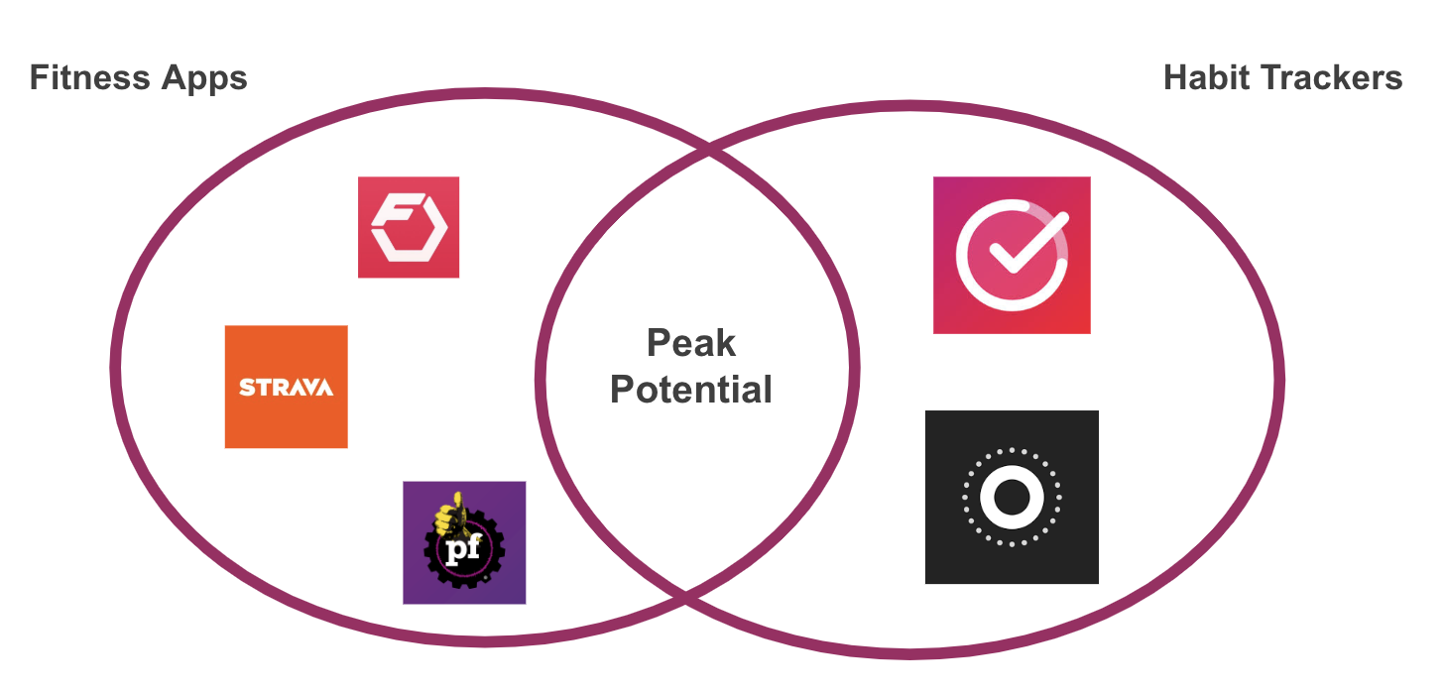

### *2. Future features*

Initial product:

* Peak Potential is initially going to have these features:
  + Gym attendance: "Selfie” validation
  + Cohort competition: The users are going to be group in cohort that is going to build community-driven accountability (Cohort competition)
  + Fitness dictionary: where users can look up exercises to do
  + Analytics: Charts to see your gym progress.
* These features will play the pivotal role in helping users build a consistent habit of going to the gym.

Iteration 1:

**Premium Subscription Model** – Offering diet tracking, nutritional advice, and personalized fitness plans.

Iteration 2:

**Live or AI-Powered Fitness Coaching** – Implementing on-demand workouts or AI-generated personalized fitness feedback to effectively guide users.

Iteration 3:

***Wearable Device Integration*** *–* Future expansion could involve integrating real-time fitness tracking through smartwatches, heart rate monitors, or wearable devices to provide even more personalized insights.

### Conclusion:

The current Peak Potential app aligns well with the company’s vision and complements its existing offerings. More importantly, it opens up multiple future growth avenues, making it a strategically sound product.

**Team Members**

* Avi Bedi → CEO
  + avinashbedi2024@u.northwestern.edu
  + **Leadership and Vision:** Avi has demonstrated strong leadership skills and a clear vision for projects, making him ideal for steering the company's strategic direction.
  + **Communication Skills:** Excellent at communicating and negotiating with stakeholders, ensuring the company's message is effectively conveyed.
* Arjun Gupta → CFO
  + arjungupta2025@u.northwestern.edu
  + **Financial Expertise:** Strong background in economics and finance, crucial for managing the company’s financial strategy and operations.
  + **Analytical Skills:** Proficient in financial modeling and analysis, enabling effective budget management and financial forecasting.
* Aly Maknojia → CTO
  + alymuhammadmaknojia2025@u.northwestern.edu
  + **Technical Skills:** Deep understanding of software development and system architecture, vital for leading the technological development of the product.
  + **Innovation:** Proven track record in innovative tech solutions, aligning with the company's mission to create cutting-edge fitness technology.
* Claudia → CMO
  + claudiabenitesantonio2025@u.northwestern.edu
  + **Marketing Acumen:** Extensive experience in digital marketing and branding, crucial for driving the company's marketing strategy and user acquisition.
  + **Creative Strategy:** Demonstrates creative insight into market trends and consumer behavior, essential for tailoring effective marketing campaigns.
* Ziduo (Alex) Sui → CDO
  + ZiduoSui2025@u.northwestern.edu
  + **Design Expertise:** Profound skills in UX/UI design, critical for ensuring the product is user-friendly and aesthetically pleasing.
  + **User-Centric Approach:** Focuses on creating designs that meet user needs and enhance user satisfaction.
* Ruoyu → CIO
  + ruoyuxiong2026@u.northwestern.edu
  + **Information Systems Management:** Strong background in managing information systems, vital for overseeing the company's IT infrastructure.
  + **Strategic IT Planning:** Ability to plan and implement strategic IT initiatives that support the company's overall goals.

**Go/No Go Recommendation**

Our decision to move from the Market Requirements Document (MRD) to the Product Requirements Document (PRD) is based on verified customer interviews, market validation, and strategic fit within the fitness industry.

### Key Factors Supporting the Go Decision:

1. Customer Validation: Interviews with high school and college-aged individuals confirmed that lack of consistency, accountability, and structured guidance are major pain points in fitness. The need for a habit-focused fitness solution was reinforced through qualitative feedback and behavioral insights.
2. Market Opportunity: The fitness tech market is growing rapidly, with Gen Z and young adults actively seeking accessible, engaging, and goal-oriented fitness solutions. Our bottom-up market analysis confirms a large TAM ($7–12 billion globally) with high adoption potential.
3. Strategic Fit & Differentiation: Unlike traditional fitness apps, Peak Potential is uniquely positioned as a behavior-change and habit-building platform, differentiating it from competitors focused solely on tracking workouts or offering generic plans.

### Confidence in the Decision:

We are moving forward with the PRD because we have clear customer insights, strong market validation, and a well-defined strategy to capture and retain users. This ensures that Peak Potential is not just a fitness app but a sustainable solution for long-term engagement and habit formation.

**Customer Research Data Appendices**

**Appendix 1**

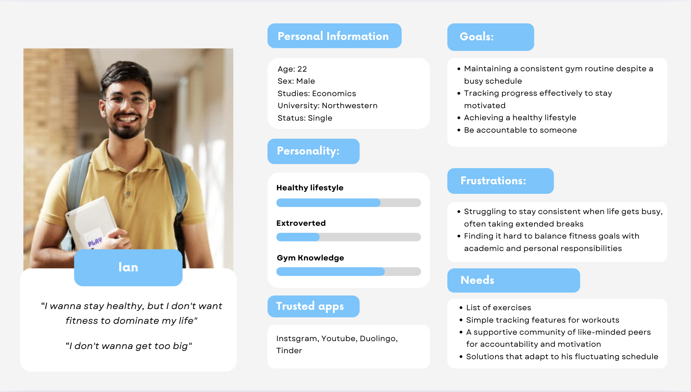

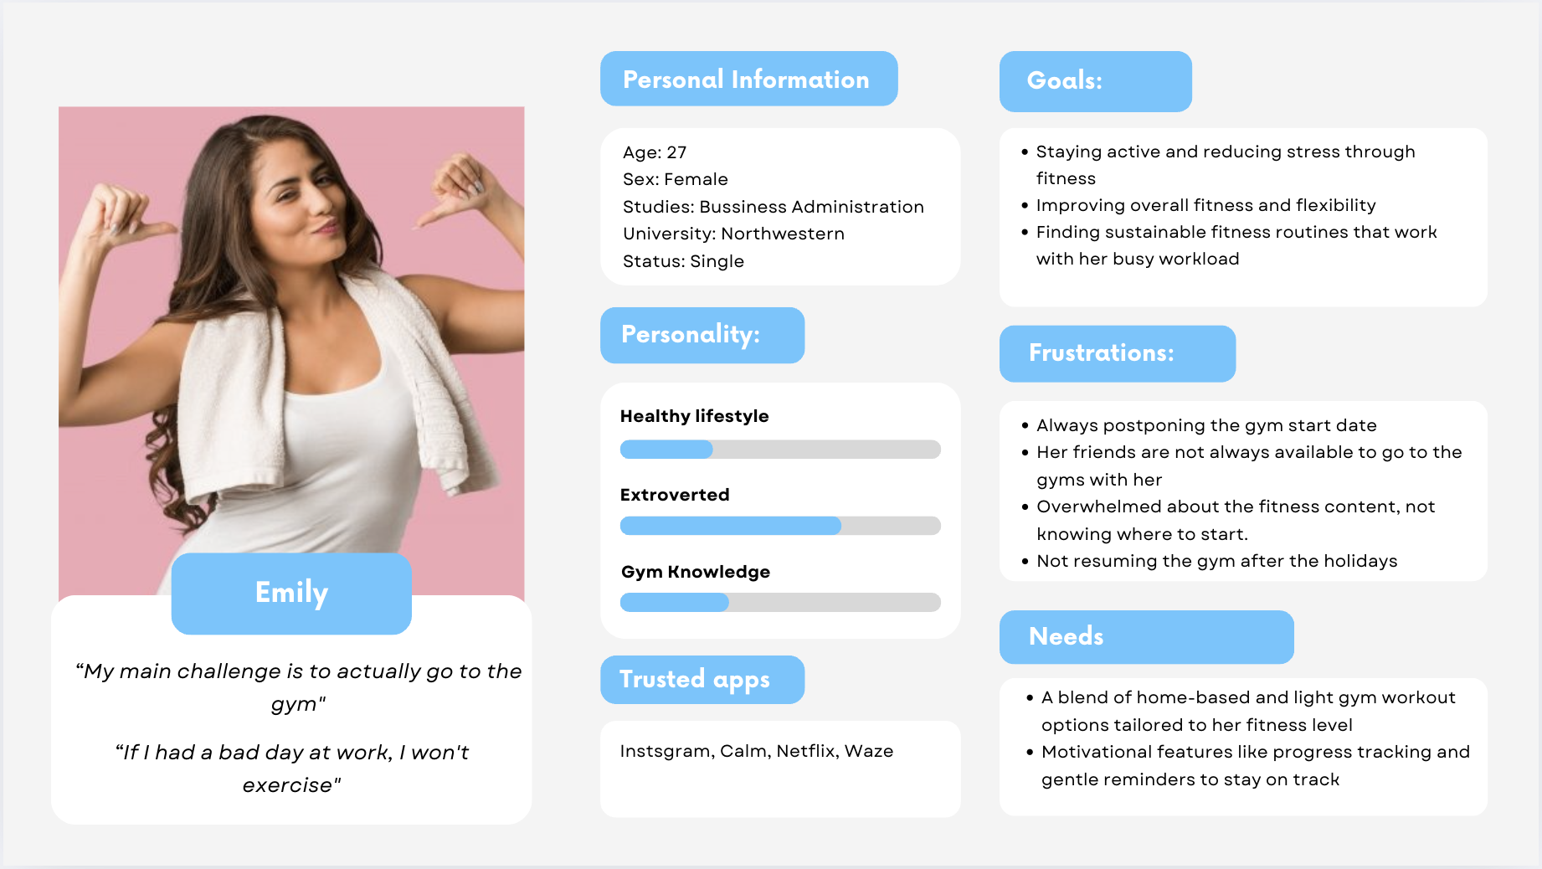

**Appendix 2: Habit tracking apps:**

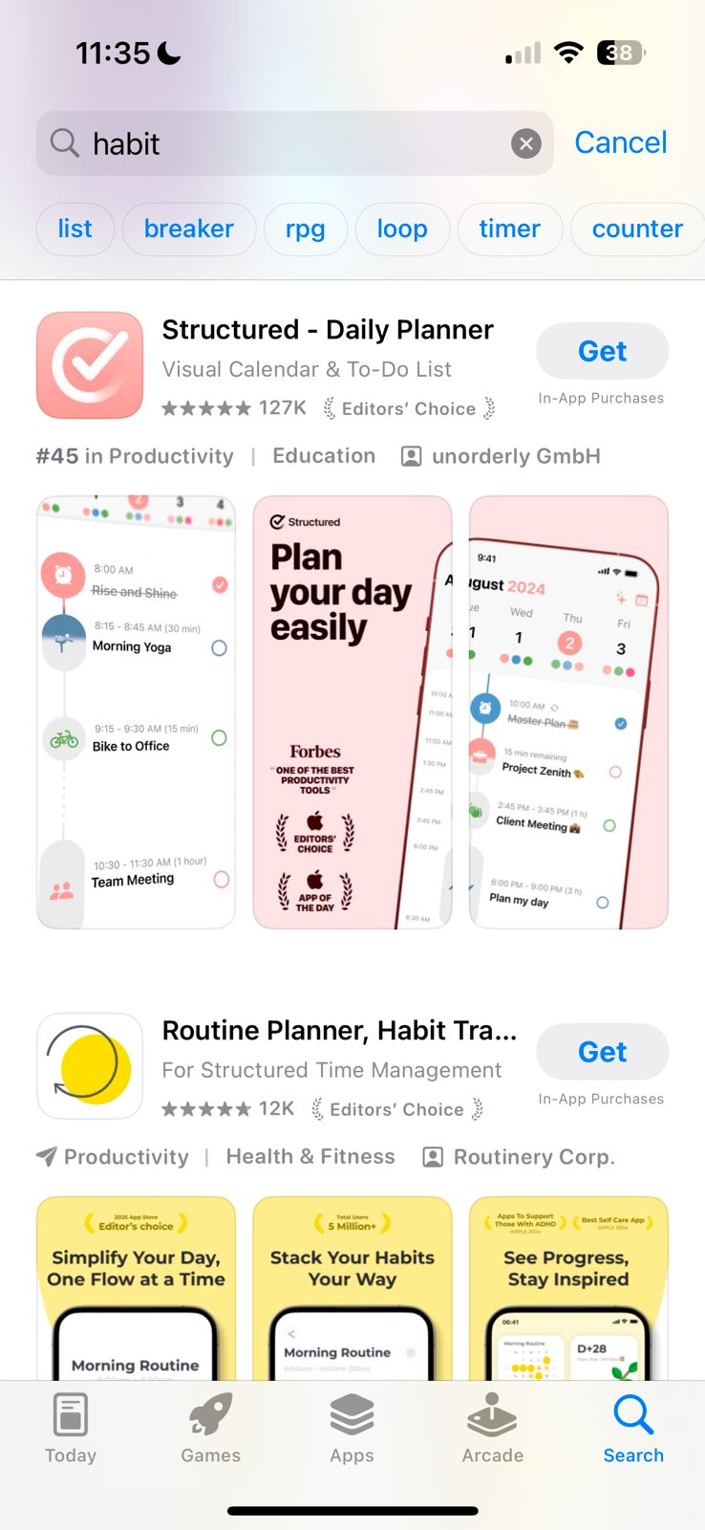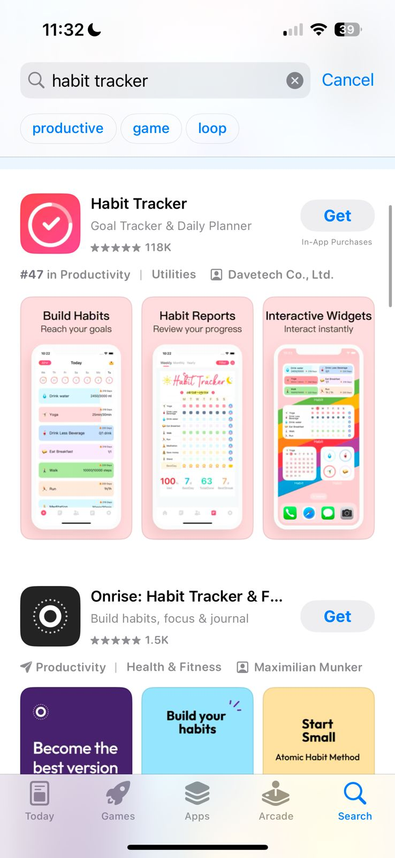

**Appendix 3: Motivational quotes**

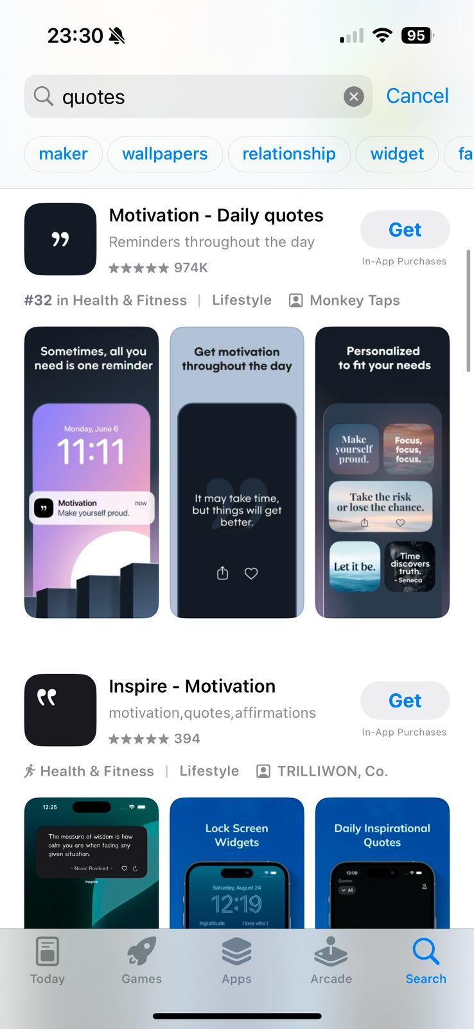

## Customer Discovery and Research Summary

### Research Process

We conducted qualitative interviews with 20 college students to identify key barriers to fitness consistency. Participants were selected from gym communities, university fitness groups, and social media platforms to ensure diverse fitness levels and schedules.

### Key Findings

1. Gym Anxiety & Fear of Judgment – Many students hesitate to try new exercises due to fear of doing them incorrectly.
2. Lack of Structure – Most participants walk into the gym without a plan, leading to inconsistency.
3. Struggling with Consistency – Students tend to work out consistently for a few weeks, then stop due to workload or loss of motivation.
4. Progress Tracking is Tedious – Users want to track results but find manual logging inconvenient.

### Research Instruments:

**Structured Interviews**

* Focused on fitness habits, challenges, and motivation.
* Example questions:
  + *What prevents you from being consistent?*
  + *Have you ever felt intimidated in the gym? Why?*

### How This Informs Our App:

* Guided beginner-friendly routines to reduce gym anxiety.
* Streak tracking & habit reinforcement to maintain engagement.
* Automated progress tracking to remove the hassle of manual logging.